

Girl’s Minor Hockey

Alvinston, Watford, Petrolia Arenas

Lambton County, Ontario

May 1, 2025

Dear Branch Manager:

RE: LAMBTON ATTACK GIRLS HOCKEY ASSOCIATION TEAM BANK ACCOUNTS FOR THE 2025-2026 SEASON

Please accept this letter as verification that the Lambton Attack _________ team is required by the Lambton Attack Girl’s Hockey Association to open a team bank account for the 2025-2026 season only under the name of Lambton Attack _________. All team transactions, deposits and withdrawls will be documented through their team account and two financial statements (budgets) will be provided to the Lambton Attacks Girl’s Hockey Association (December 2025 and April 2026). We respectfully request that banking institutions waive or provide minimal maintenance costs for these accounts as they are for community purposes only and will all be closed upon the completion of the season. _______________________ and _______________________ will open and have signing authority of this account for the 2025-2026 season only. The team signing officers are both required to sign all withdrawls and cheques for the account. If you require further information, you may contact a Lambton Attack Girl’s Hockey Executive Member.

Thank you,

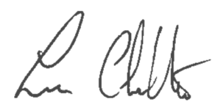

Lee Charlton,

President Lambton Attack Girls Hockey Association